  
  ADRC/AGING &
  medicare 101
    - September 4, 2025
    - Noon – 2 pm
    - and
    - September 16, 2025
    - 5 – 7 pm
  Lafayette Hospital + Clinics, Conference Room
  211 Bev Anderson Dr., Darlington, WI
  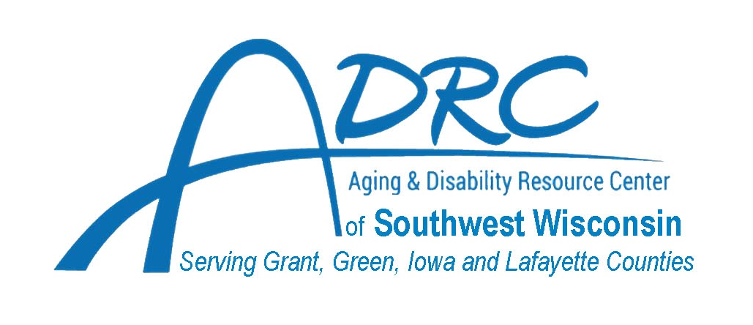
  The Aging Disability Resource Center Staff will be conducting the FREE, unbiased informational session with time allotted for questions and answers. Please call the ADRC to register at (608) 776-4960. We hope to see you there!
  
  Retiring in 2025?
  Are you or a loved one turning 65 in 2025?
  Do you know your Health Insurance and Long-Term Care options?
  Do you have questions about a loved one’s Medicare Insurance and other options?
  Join us and get your questions answered!
  Contact Whitney THompson, Dementia Care Specialist for the Aging & Disability Resource Center of Southwest Wisconsin for more information:
  608-426-4295

